As shown via
immunohistochemistry (IHC), human iPS cell colonies express markers
common to pluripotent cells, including alkaline phosphatase (AP), Tra-1-81,
NANOG, OCT4, Tra-1-60, SSEA3 and SSEA4.
4,6-Diamidino-2- phenylindole (DAPI) staining indicates the total cell content per field.
Fibroblasts surrounding human iPS colonies serve as internal negative
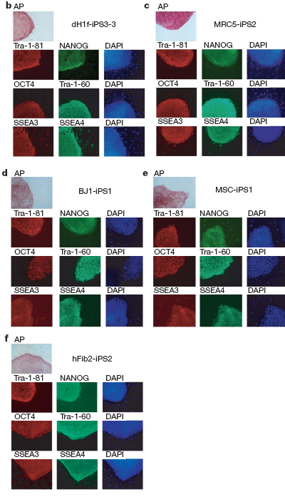
controls for IHC staining.

