
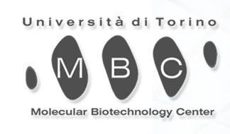

POSITION AVAILABLE

The recently established Functional Genomics Core Facility (FGCF) at the Molecular Biotechnology Center of the University of Turin, Turin, Italy is actively recruiting a motivated individual for a post-doctoral position.
The focus of the research is to identify and validate novel therapeutic targets in haematological malignancies and in solid tumors through semi-automatic functional screenings using shRNA, cDNA, and small-molecule libraries.

The ideal candidate should hold either a Ph.D. or M.S. degree, have an interest in oncology and documented experience in cellular and molecular biology, gene silencing, automation, and bioinformatics. Experience in mouse/animal models is desirable. Excellent knowledge of English, good interpersonal and communication skills are required. Candidates should have less than five years post-doctoral experience.

Qualified applicants should send a c.v. to Prof. Roberto Piva (roberto.piva@unito.it) and/or Prof. Giorgio Inghirami (giorgio.inghirami@unito.it).

Applications should include:
- detailed curriculum vitae with publications list
- description of research interests
- contact information of two references

The position is open to candidates from all countries holding equivalent degrees. Salary will be commensurate with qualification and experience.

